SPRINT -2

|  |  |
| --- | --- |
| **DATE** | **14November 2022** |
| **TEAM ID** | **~~PNT2022TMID08724~~** |
| **PROJECT**  **NAME** | **SMART WASTE MANAGEMENT FOR**  **METROPOLITAN CITIES** |

**Code for Data Transfer fromSensors**

#include <LiquidCrystal_I2C.h> #include <WiFi.h>

LiquidCrystal_I2C lcd(0x27, 16, 2); // I2C address 0x3F, 16 column and 2 rows

int trigPin = 2; // TRIG pin int echoPin = 15; // ECHO pin

float duration_us, distance_cm,distance;

void setup() {

lcd.init(); // initialize the lcd lcd.backlight();

pinMode(5,OUTPUT); pinMode(18,OUTPUT); pinMode(19,OUTPUT); pinMode(23,OUTPUT); pinMode(34,INPUT); pinMode(14,OUTPUT);

// open the backlight

pinMode(trigPin, OUTPUT); // config trigger pin to output mode pinMode(echoPin, INPUT);

**Serial**.println(9600); // config echo pin to input mode

}

void loop() { lcd.clear();

lcd.setCursor(0, 0); // start to print at the first row lcd.print("waste level: ");

lcd.print(distance);

// generate 10-microsecond pulse to TRIG pin digitalWrite(trigPin, HIGH); delayMicroseconds(10); digitalWrite(trigPin, LOW);

// measure duration of pulse from ECHO pin duration_us = pulseIn(echoPin, HIGH);

// calculate the distance distance_cm = 0.017 * duration_us; distance=400-distance_cm; if(digitalRead(34))

{

**Serial**.println("Motion Detected");

**Serial**.println("Lid Opened");

lcd.setCursor(0, 1); // start to print at the first row lcd.print("LID OPENED ");

digitalWrite(14, HIGH);

}

else

{

digitalWrite(14, LOW);

lcd.setCursor(0, 1); // start to print at the first row lcd.print("LID CLOSED ");

}

digitalWrite(5,HIGH); digitalWrite(18,LOW); digitalWrite(19,LOW); digitalWrite(23,LOW); if(distance>=175)

{

digitalWrite(18,HIGH); digitalWrite(5,LOW); digitalWrite(19,LOW); digitalWrite(23,LOW);

}

if(distance>=275)

{

digitalWrite(19,HIGH); digitalWrite(5,LOW); digitalWrite(18,LOW); digitalWrite(23,LOW);

}

if(distance>=375)

{

digitalWrite(23,HIGH); digitalWrite(18,LOW); digitalWrite(5,LOW); digitalWrite(19,LOW);

}

delay(500);

}

**Connection Diagram**

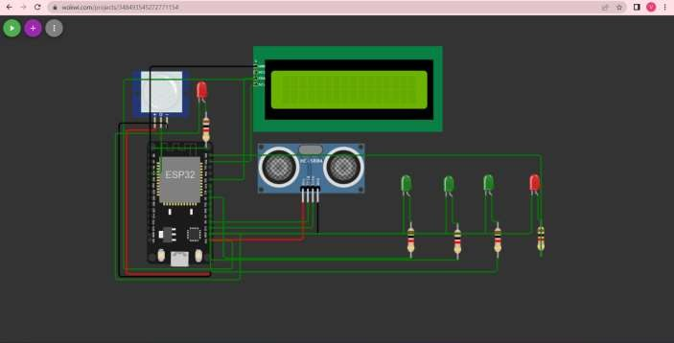

**Working**

